
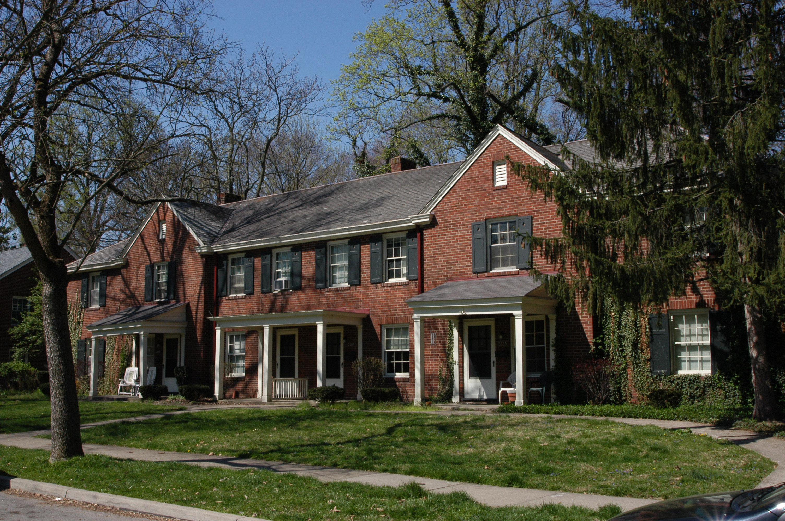
3883 Beech Street

Unit includes…

* Two-bedroom townhouse

* Large eat-in kitchen with pantry

* Full basement with washer and dryer hook-ups

* Fenced-in backyard with private patio

* Secure garage

* Cable Ready

* Pet-friendly environment, call for details.

$695 per month



For Inquiries or to make an appointment for a showing for this townhouse, call
513-861-2861 or 513-617-5747

